**ReceiptMe**

1. **Introduction**

For our end of stack project, the agreed-on project is to establish a platform that can handle all the invoices and the receipts received from all product’s distributors to a certain store.

1. **Our team members:**

* Ali Ahmed
* Khaled Ammar
* Amin Hotari
* Amin Elyaan

1. Project Overview:

While piles of hardcopy invoices are not functional in today’s productivity, a system that can handle your incoming receipts is what you need to have easy management in your store.

Using our application, you can permit an admin for your employees on inserting level only for any received receipts from your store products distributors. Employees will have view access only to the products they have inserted, keeping in mind that the original hardcopy receipts will be attached with each insertion.

As a second base of authorization, your accountant will have overview access for all the incoming products and invoices from all employees.

As a third-based authorization, the admin role has all the access to the system, they can view, update and delete any products or invoices, as well as give permission to new admins, accountants, and employees.

1. **ERD screenshot**

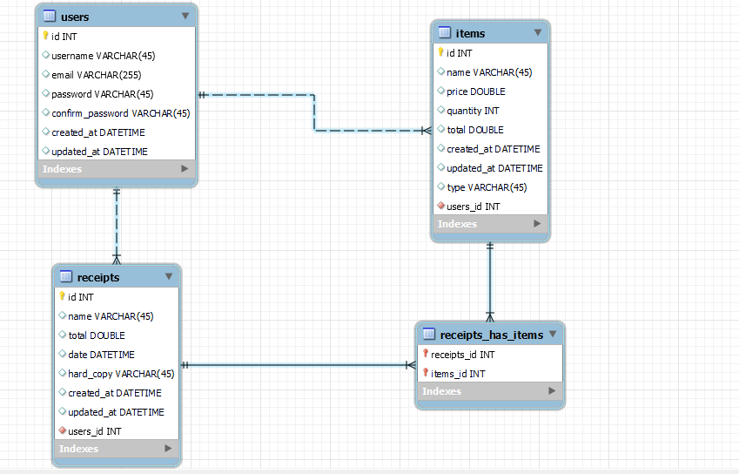

1. **Wireframe screenshot**

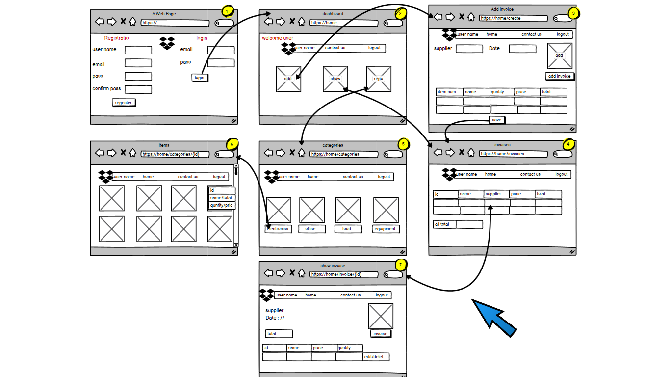

1. **Links:**

* [GitHub](https://github.com/alirabah93/easyReceipter)
* [Trello](https://trello.com/b/l2EhM4rN/java-project)